hoose a style, a size, and any of our fabulous fabrics.

* [[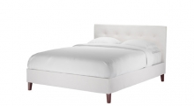](http://www.sofa.com/shop/beds/marais)](http://www.sofa.com/shop/beds/marais)

[marais beds](http://www.sofa.com/shop/beds/marais)

* [[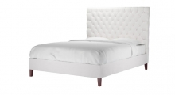](http://www.sofa.com/shop/beds/valentin)](http://www.sofa.com/shop/beds/valentin)

[valentin beds](http://www.sofa.com/shop/beds/valentin)

* [[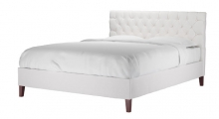](http://www.sofa.com/shop/beds/st-germain)](http://www.sofa.com/shop/beds/st-germain)

[st germain beds](http://www.sofa.com/shop/beds/st-germain)

* [[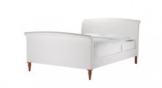](http://www.sofa.com/shop/beds/argentario)](http://www.sofa.com/shop/beds/argentario)

[argentario beds](http://www.sofa.com/shop/beds/argentario)

* [[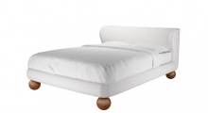](http://www.sofa.com/shop/beds/livingstone)](http://www.sofa.com/shop/beds/livingstone)

[livingstone beds](http://www.sofa.com/shop/beds/livingstone)

* [[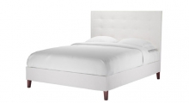](http://www.sofa.com/shop/beds/buttons)](http://www.sofa.com/shop/beds/buttons)

[buttons beds](http://www.sofa.com/shop/beds/buttons)

* [[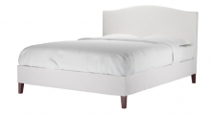](http://www.sofa.com/shop/beds/drayson-upholstered)](http://www.sofa.com/shop/beds/drayson-upholstered)

[drayson beds](http://www.sofa.com/shop/beds/drayson-upholstered)

* [[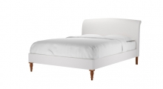](http://www.sofa.com/shop/beds/florentine)](http://www.sofa.com/shop/beds/florentine)

[florentine beds](http://www.sofa.com/shop/beds/florentine)

* [[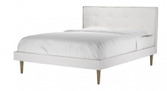](http://www.sofa.com/shop/beds/laslo)](http://www.sofa.com/shop/beds/laslo)

[laslo beds](http://www.sofa.com/shop/beds/laslo)

* [[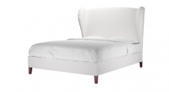](http://www.sofa.com/shop/beds/angelica)](http://www.sofa.com/shop/beds/angelica)

[angelica beds](http://www.sofa.com/shop/beds/angelica)

* [[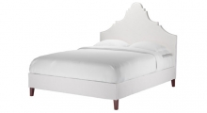](http://www.sofa.com/shop/beds/inferno)](http://www.sofa.com/shop/beds/inferno)

[inferno beds](http://www.sofa.com/shop/beds/inferno)

* [[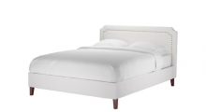](http://www.sofa.com/shop/beds/louis)](http://www.sofa.com/shop/beds/louis)

[louis beds](http://www.sofa.com/shop/beds/louis)

* [[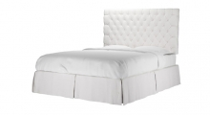](http://www.sofa.com/shop/beds/valentin-with-storage)](http://www.sofa.com/shop/beds/valentin-with-storage)

[valentin beds with storage](http://www.sofa.com/shop/beds/valentin-with-storage)

* [[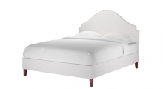](http://www.sofa.com/shop/beds/kandahar)](http://www.sofa.com/shop/beds/kandahar)

[kandahar beds](http://www.sofa.com/shop/beds/kandahar)

* [[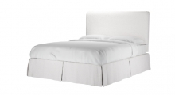](http://www.sofa.com/shop/beds/sophie-with-storage)](http://www.sofa.com/shop/beds/sophie-with-storage)

[sophie beds with storage](http://www.sofa.com/shop/beds/sophie-with-storage)

* [[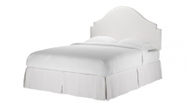](http://www.sofa.com/shop/beds/kandahar-with-storage)](http://www.sofa.com/shop/beds/kandahar-with-storage)

[kandahar beds with storage](http://www.sofa.com/shop/beds/kandahar-with-storage)

* [[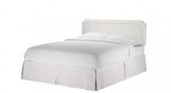](http://www.sofa.com/shop/beds/louis-with-storage)](http://www.sofa.com/shop/beds/louis-with-storage)

[louis beds with storage](http://www.sofa.com/shop/beds/louis-with-storage)

* [[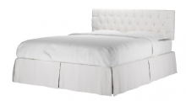](http://www.sofa.com/shop/beds/st-germain-with-storage)](http://www.sofa.com/shop/beds/st-germain-with-storage)

[st germain beds with storage](http://www.sofa.com/shop/beds/st-germain-with-storage)

* [[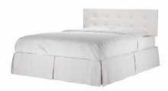](http://www.sofa.com/shop/beds/marais-with-storage)](http://www.sofa.com/shop/beds/marais-with-storage)

[marais beds with storage](http://www.sofa.com/shop/beds/marais-with-storage)

* [[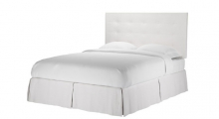](http://www.sofa.com/shop/beds/buttons-with-storage)](http://www.sofa.com/shop/beds/buttons-with-storage)

[buttons beds with storage](http://www.sofa.com/shop/beds/buttons-with-storage)

* [[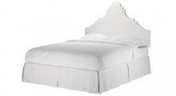](http://www.sofa.com/shop/beds/inferno-with-storage)](http://www.sofa.com/shop/beds/inferno-with-storage)

[inferno beds with storage](http://www.sofa.com/shop/beds/inferno-with-storage)

* [[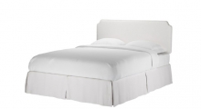](http://www.sofa.com/shop/beds/scallop-with-storage)](http://www.sofa.com/shop/beds/scallop-with-storage)

[scallop beds with storage](http://www.sofa.com/shop/beds/scallop-with-storage)

* [[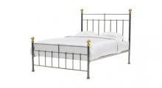](http://www.sofa.com/shop/beds/austen)](http://www.sofa.com/shop/beds/austen)

[austen beds](http://www.sofa.com/shop/beds/austen)

* [[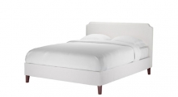](http://www.sofa.com/shop/beds/scallop)](http://www.sofa.com/shop/beds/scallop)

[scallop beds](http://www.sofa.com/shop/beds/scallop)

* [[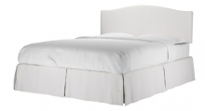](http://www.sofa.com/shop/beds/drayson-upholstered-storage)](http://www.sofa.com/shop/beds/drayson-upholstered-storage)

[drayson beds with storage](http://www.sofa.com/shop/beds/drayson-upholstered-storage)

* [[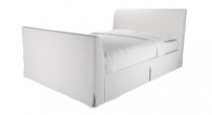](http://www.sofa.com/shop/beds/villandry)](http://www.sofa.com/shop/beds/villandry)

[villandry beds](http://www.sofa.com/shop/beds/villandry)

* [[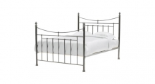](http://www.sofa.com/shop/beds/shelley)](http://www.sofa.com/shop/beds/shelley)

[shelley beds](http://www.sofa.com/shop/beds/shelley)